**Super Mall App**

**Project Setup:**

1. Navigate to - <https://github.com/Ayeshaq09/Unified-mentor-projects> You will see all 8 projects.

2. To get the projects onto your system: click on "Code" button and copy the link - <https://github.com/Ayeshaq09/Unified-mentor-projects.git>

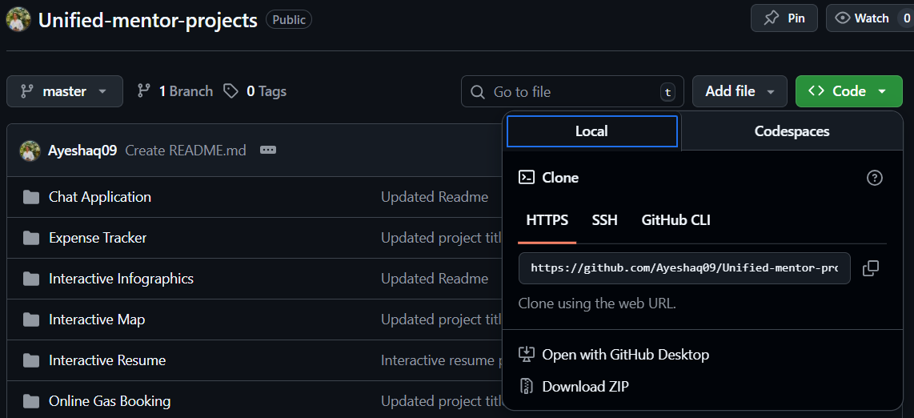



3. Open git bash and run the following command:

git clone <https://github.com/Ayeshaq09/Unified-mentor-projects.git>

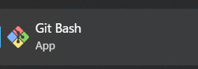

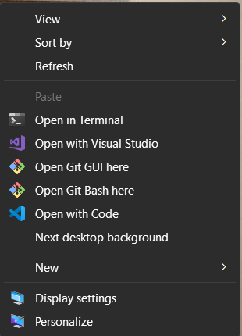



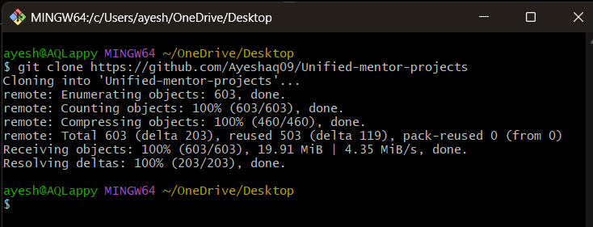



4. Once cloning is done, you get all the 8 projects onto your system.

**About the project:**

This project display products and its details and it contains dashboard module, shop module, floor module, offer module and category module.

**Features**

This application contains:

1. Login and Register forms
2. Dashboard
3. Displays all products information
4. User can view all products
5. User can view details of each product
6. User can compare details of two products
7. Admin can add/delete and modify products, shop, floor, category and offer details.

The app is mobile-responsive and is user-friendly.

**Technologies Used**

* HTML5, CSS3, JavaScript, Reactjs
* Nodejs for backend
* Firebase for data storage
* react-toastify for notifications

**Super Mall project setup:**

1. Open the folder in vscode and in terminal run – cd frontend

npm install





Then do same in backend folder

cd..

cd backend

npm install





1. Then in frontend folder add “.env.local” file with following content. (Double click on the below code snippet, a new document will open with code and then copy the content and paste it in a file named “.env.local” in **frontend** folder. This file is important and such files cannot be added in github as they contain confidential data in it.)



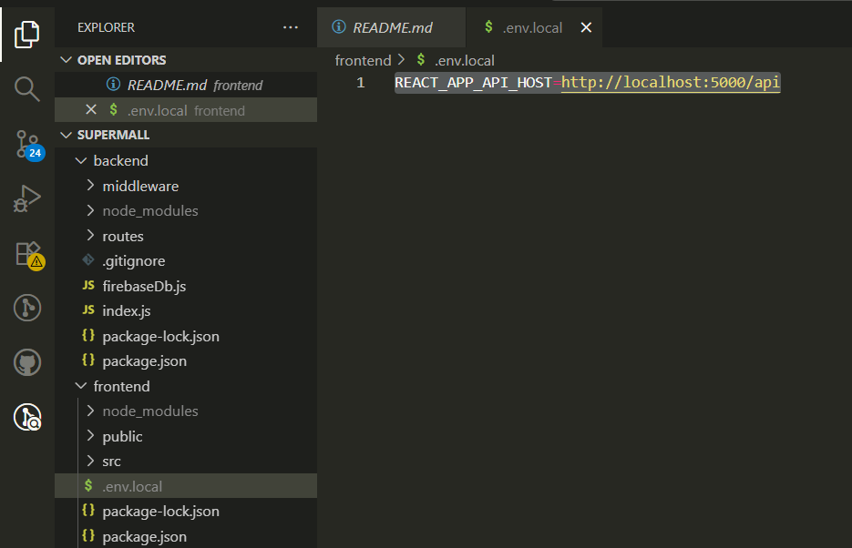

1. Then add new file named – “serviceAccountKey.json” file in **backend** folder and add the following content in it. (Double click on the below code snippet, a new document will open with code and then copy the content and paste it in a file named “serviceAccountKey.json” in **backend** folder. This file is important for the firebase connection and such files cannot be added in github as they contain confidential data in it.) 

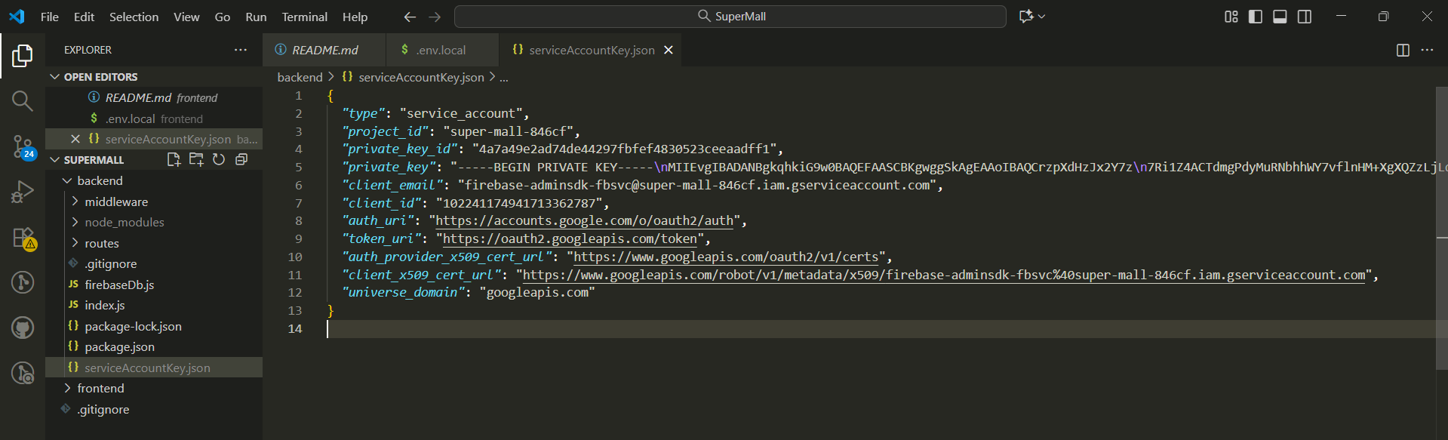

1. Then in backend folder add “.env.local” file with following content. (Double click on the below code snippet, a new document will open with code and then copy the content and paste it in a file named “.env.local” in **backend** folder. This file is important and such files cannot be added in github as they contain confidential data in it.)



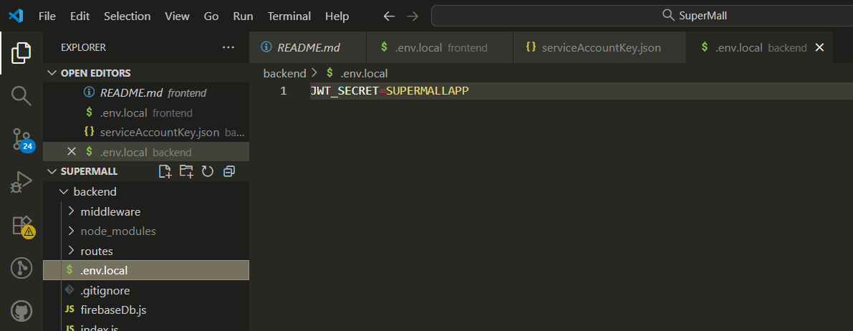

1. Then run – cd..

cd frontend

npm run both





**Functionality of the project:**

1. The application first displays the login page and if the user is new then he/she can register using register page.

Once registered the user can login.

User credentials:

email - user@gmail.com

password - user

Admin credentials:

email - mainmail.notify@gmail.com

password – admin

Login page:

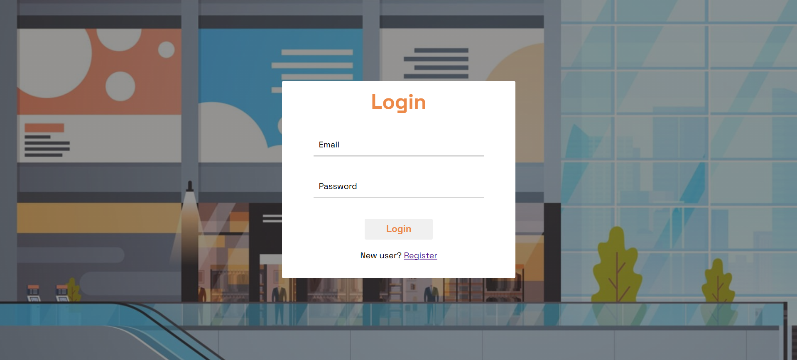

Register page:  
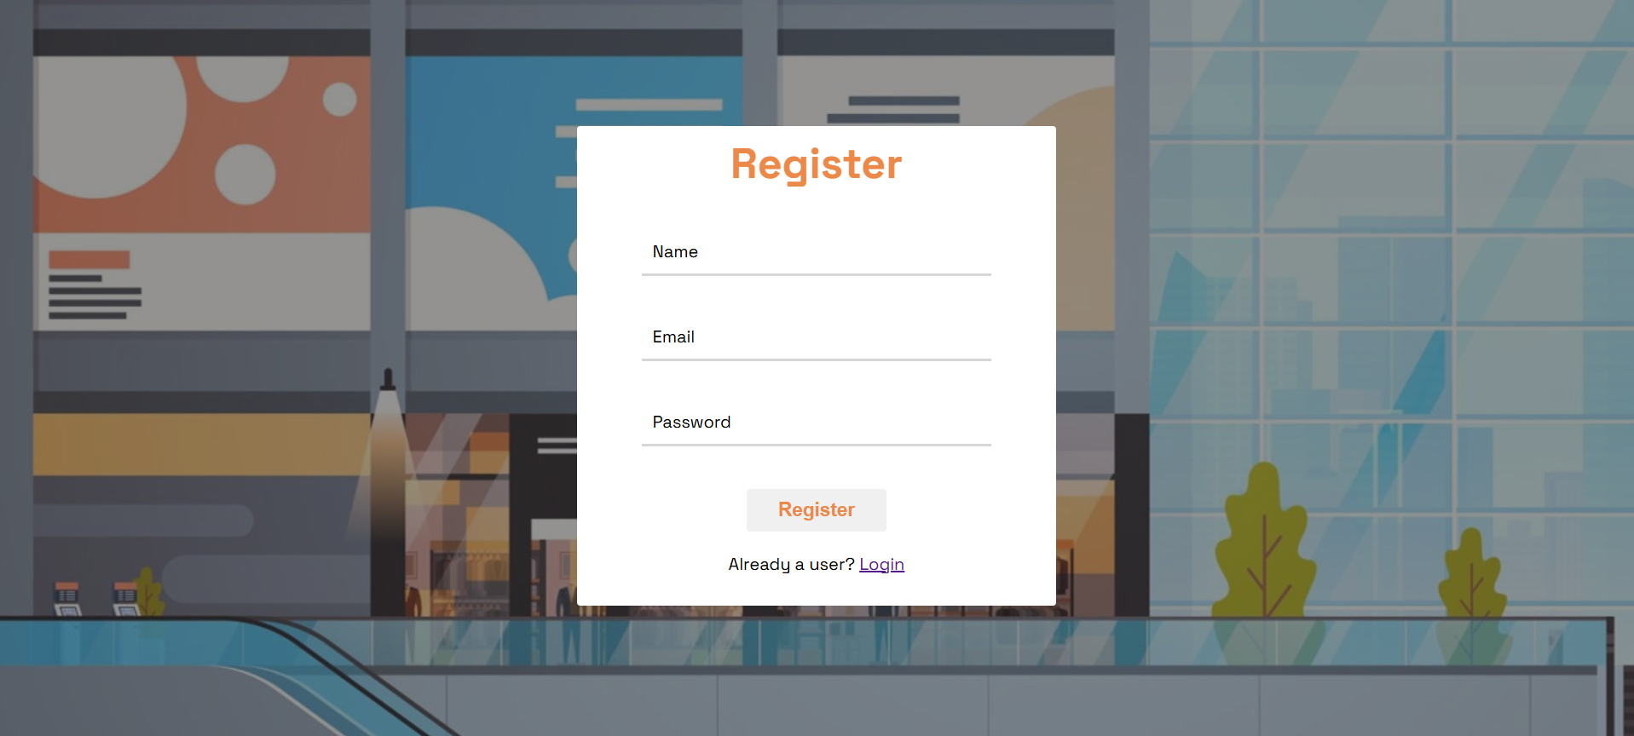

The application contains 2 modules:

1. **Admin**
2. Products

* Here you can Add Product.

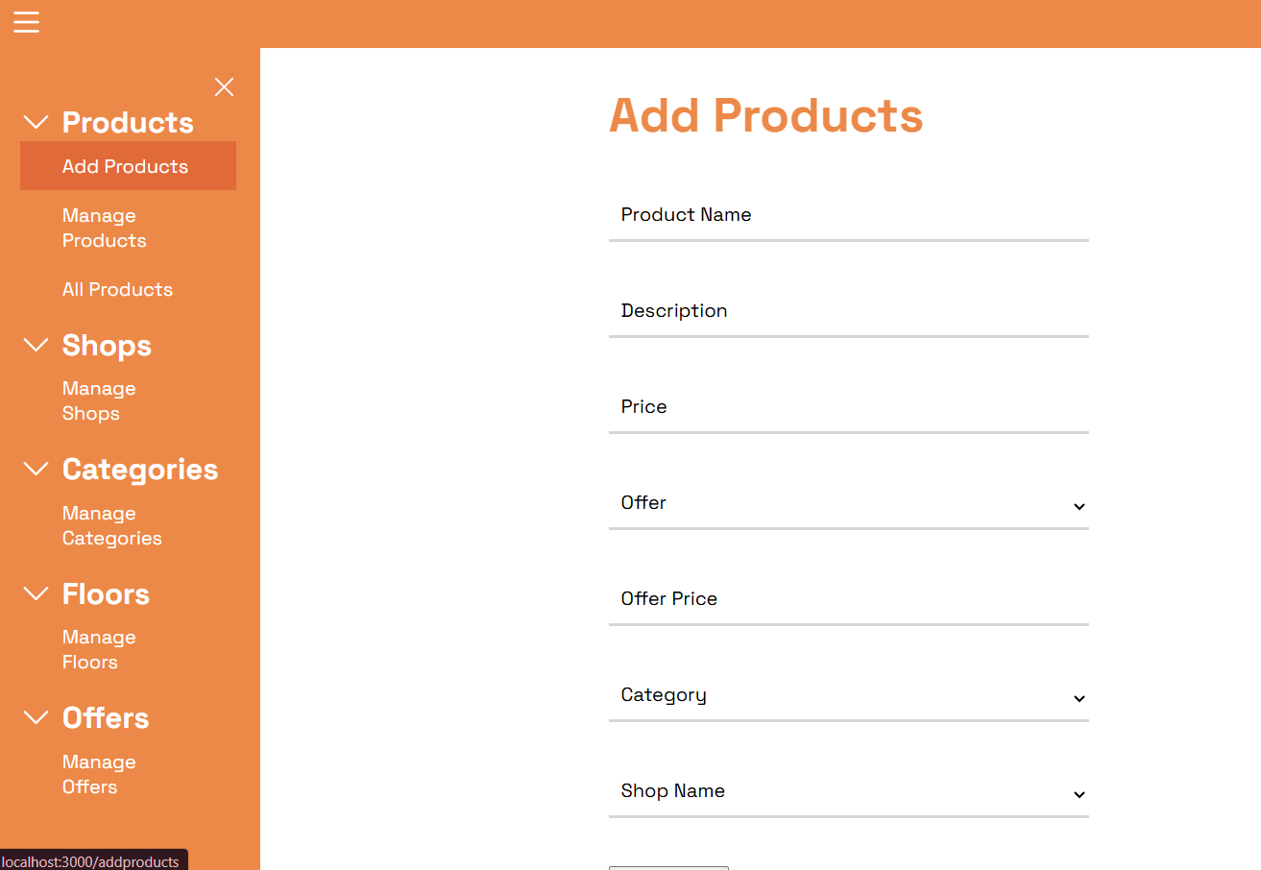

* Manage product details - upload product image, edit, delete.

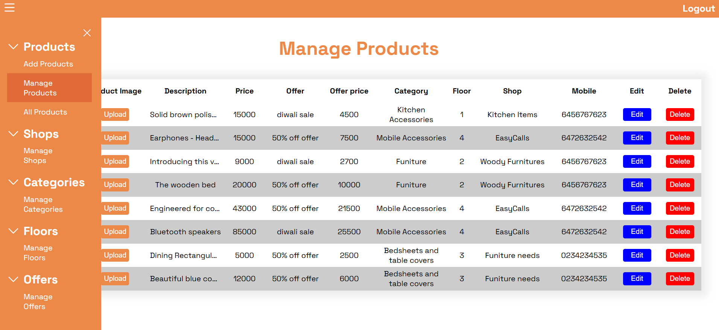

* View all products - Click on a product to view its details

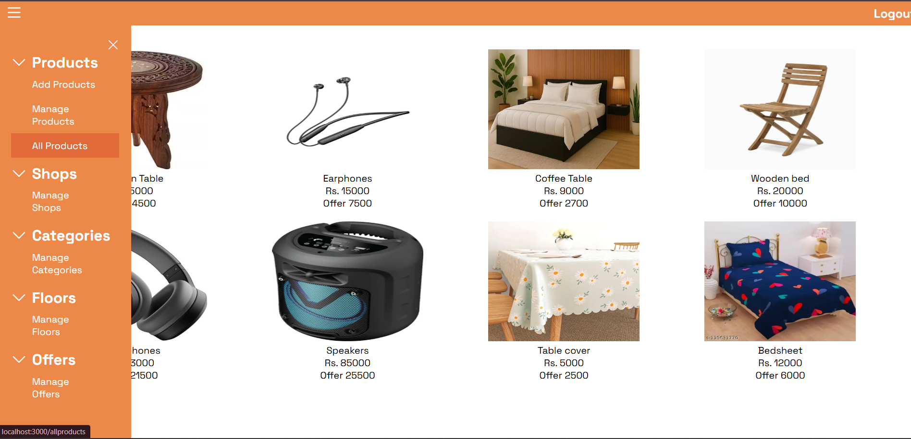

Click on ‘<- Products’ to navigate to back.

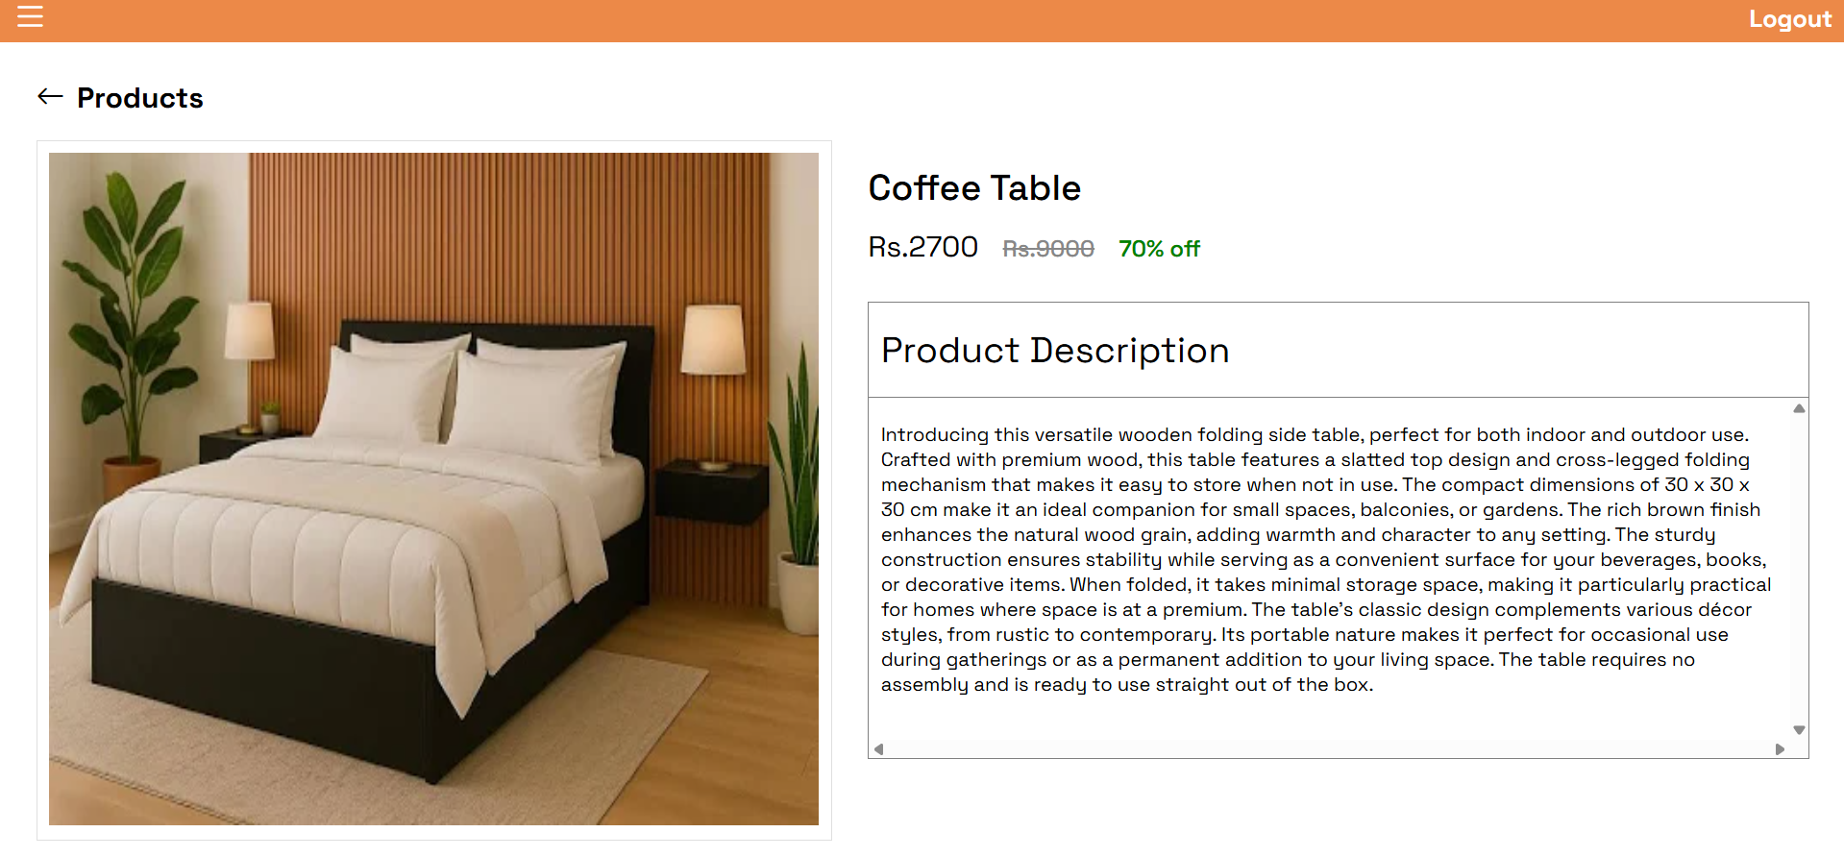



1. Shops

* Here you can add, edit, delete the shop details

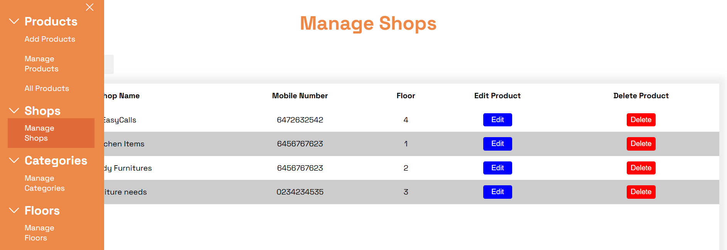

1. Categories

* Here you can add, edit, delete the category details

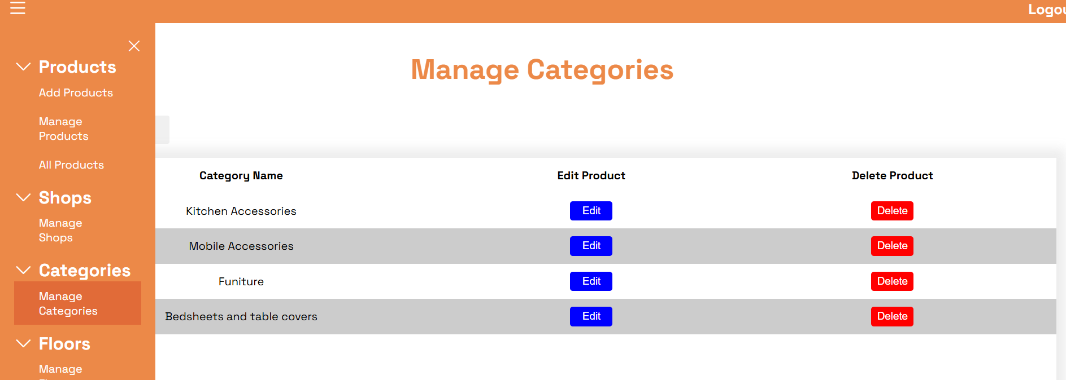

1. Floors

* Here you can add, edit, delete the floor details

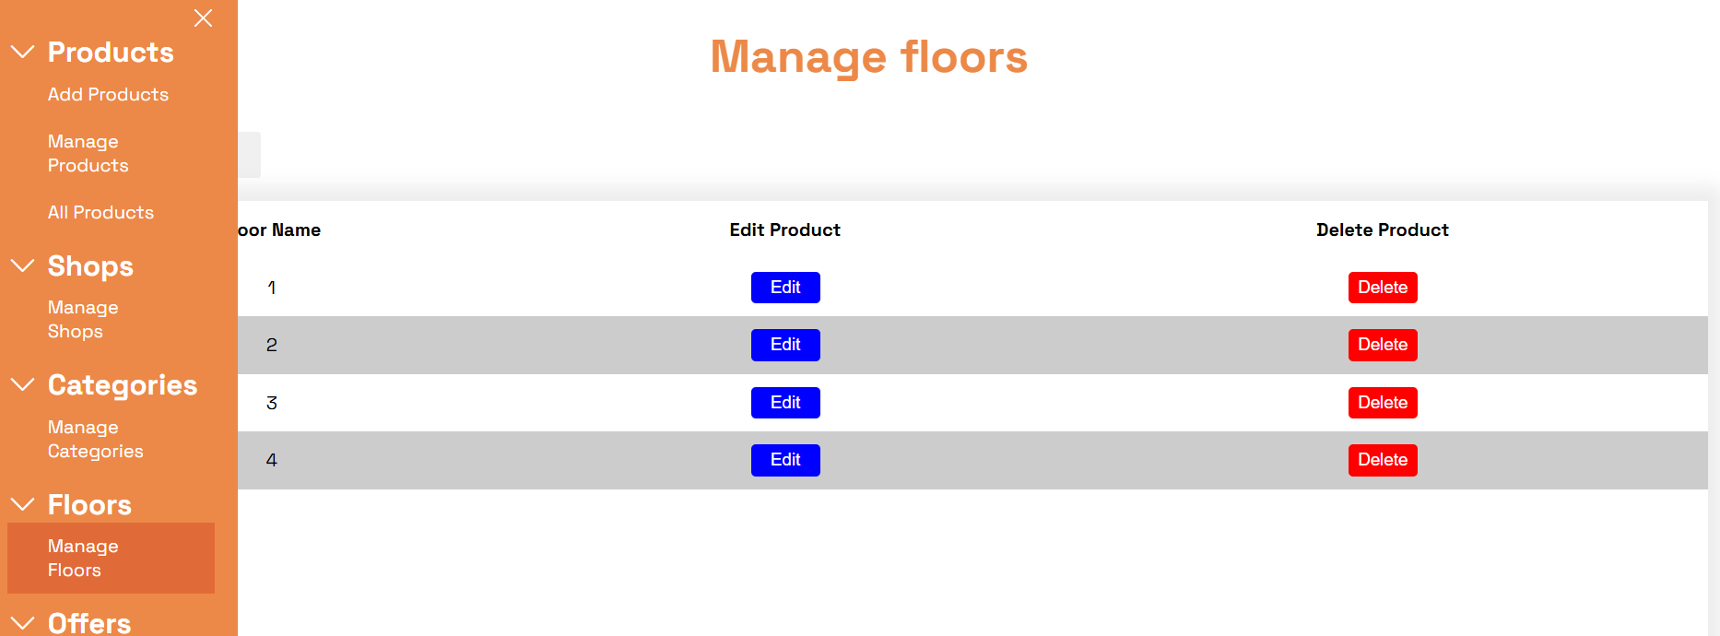

1. Offers

* Here you can add, edit, delete the offer details.

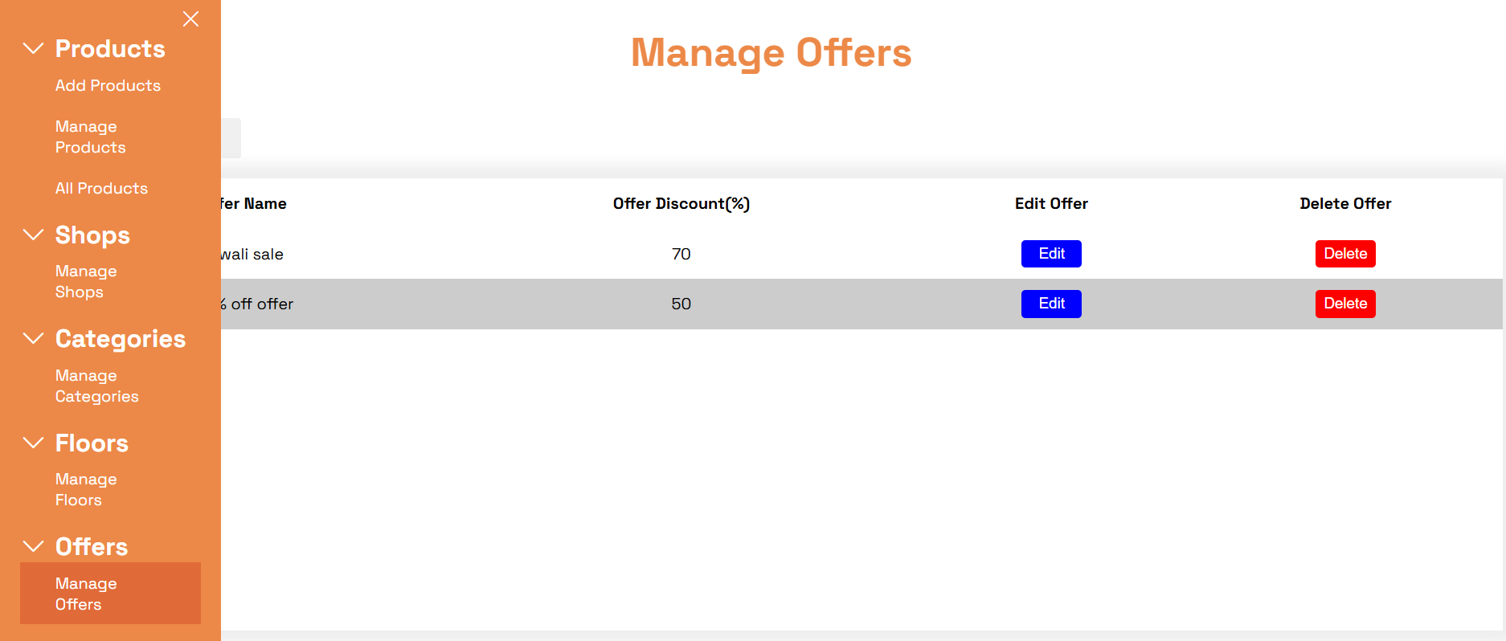

* Then the admin can logout

1. **User**
2. Products
   * The user can view all products

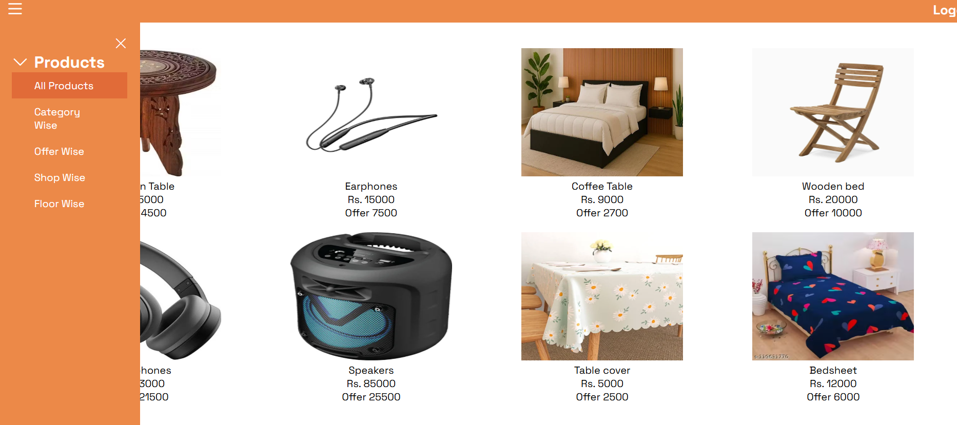

* + Click on a product to view its details

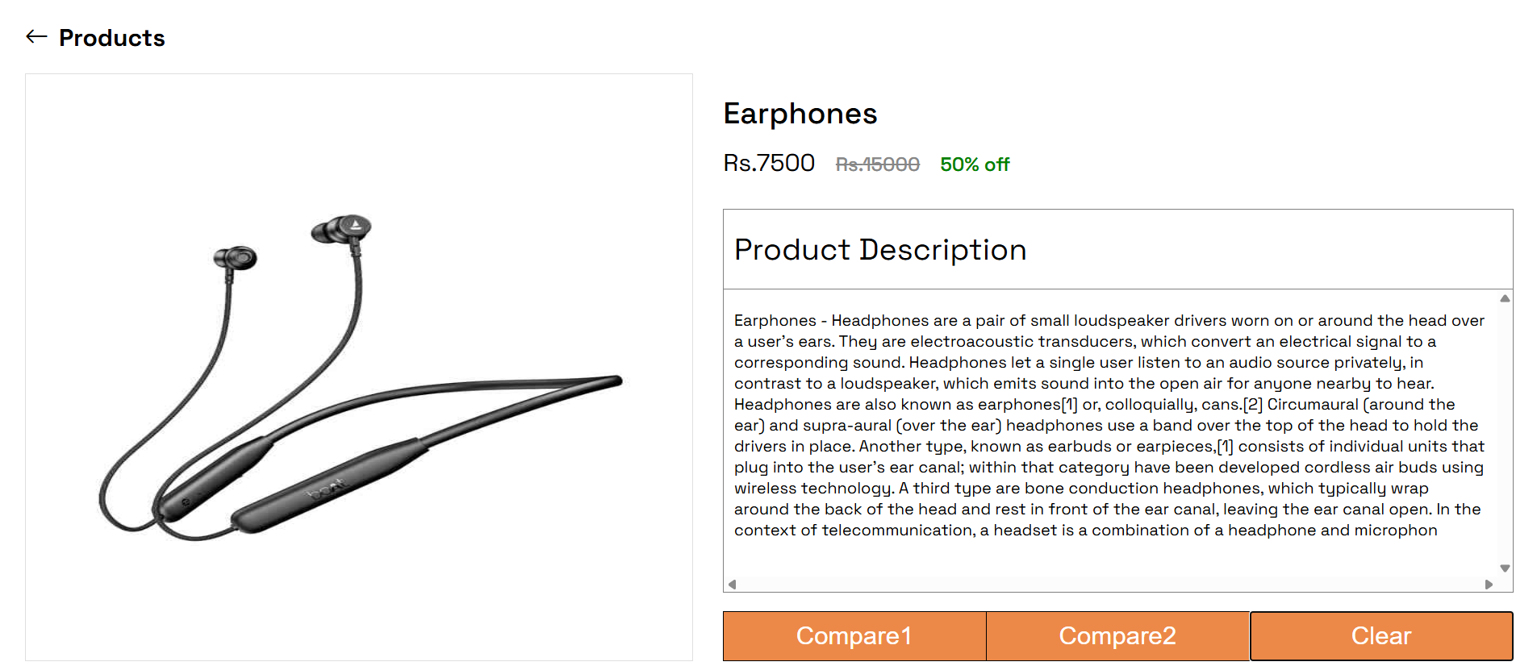

* + User can select products to compare.

Eg: - **Compare headphone and earphones** - Click on ‘Compare1’ for product 1 (Earphones) and click on ‘Compare2’ for product 2 (Headphones), it will open the ‘Compare products’ page so that you can compare product details side by side.

* Clear on clear to select different products.

Click on Compare1 button.

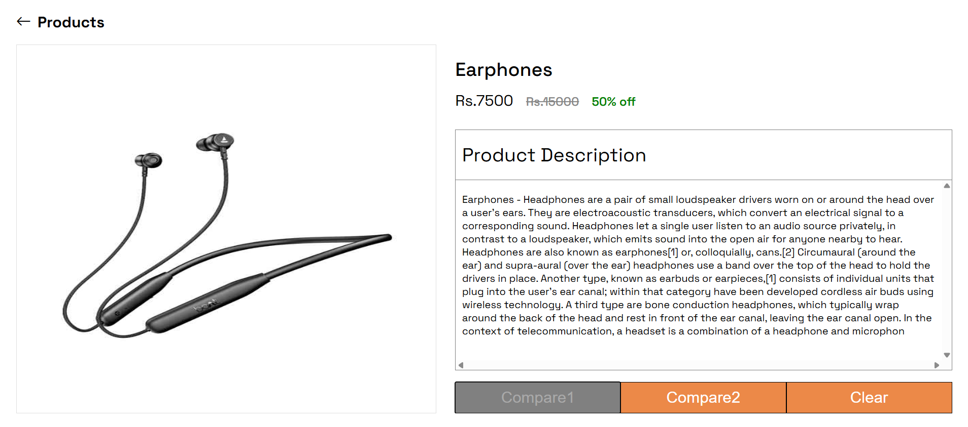



Click on Compare2 button.

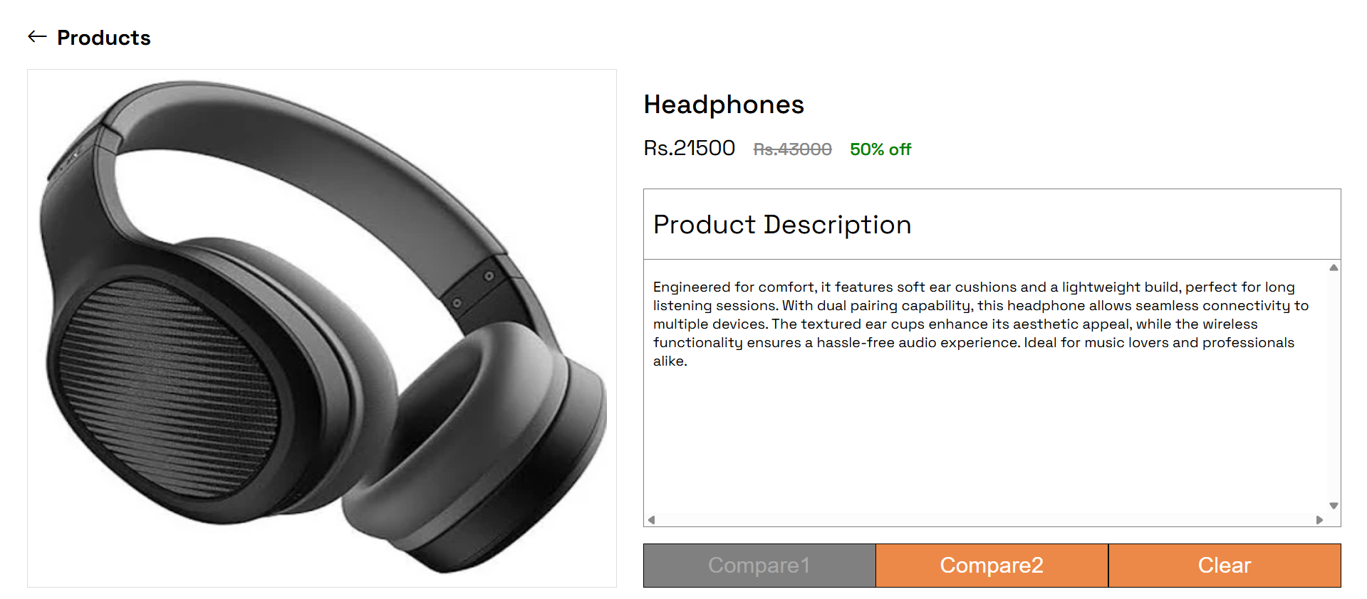

It will take you to compare products page.

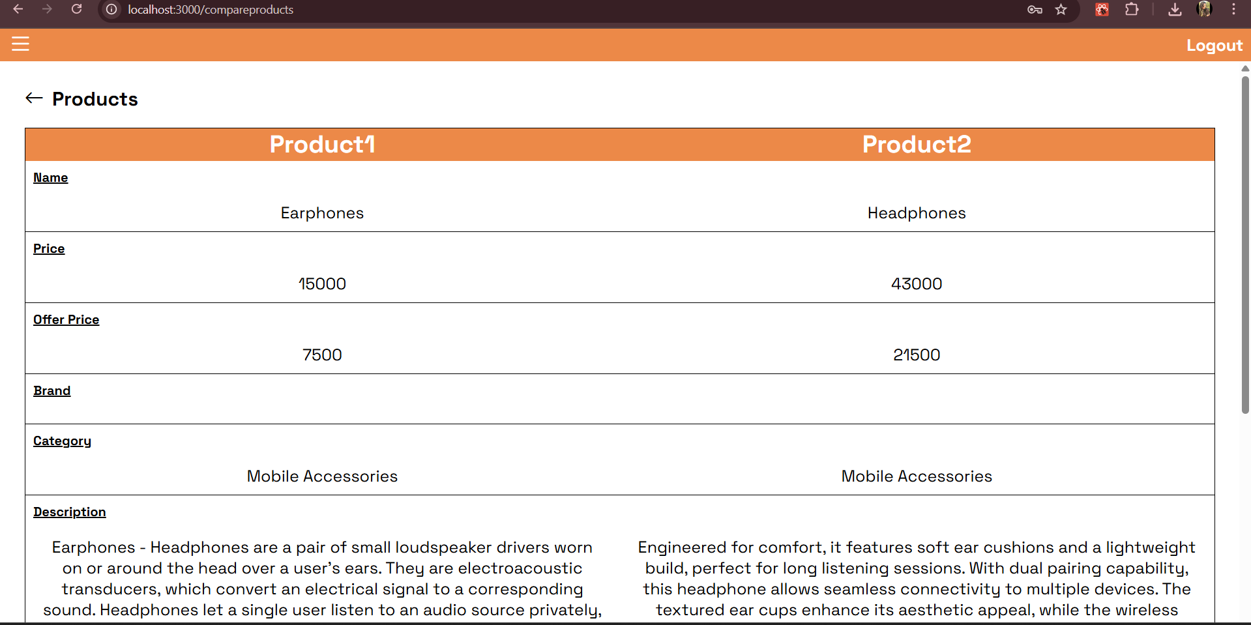

1. View products - Category wise, Offer wise, Shop wise and Floor wise.

Category wise:

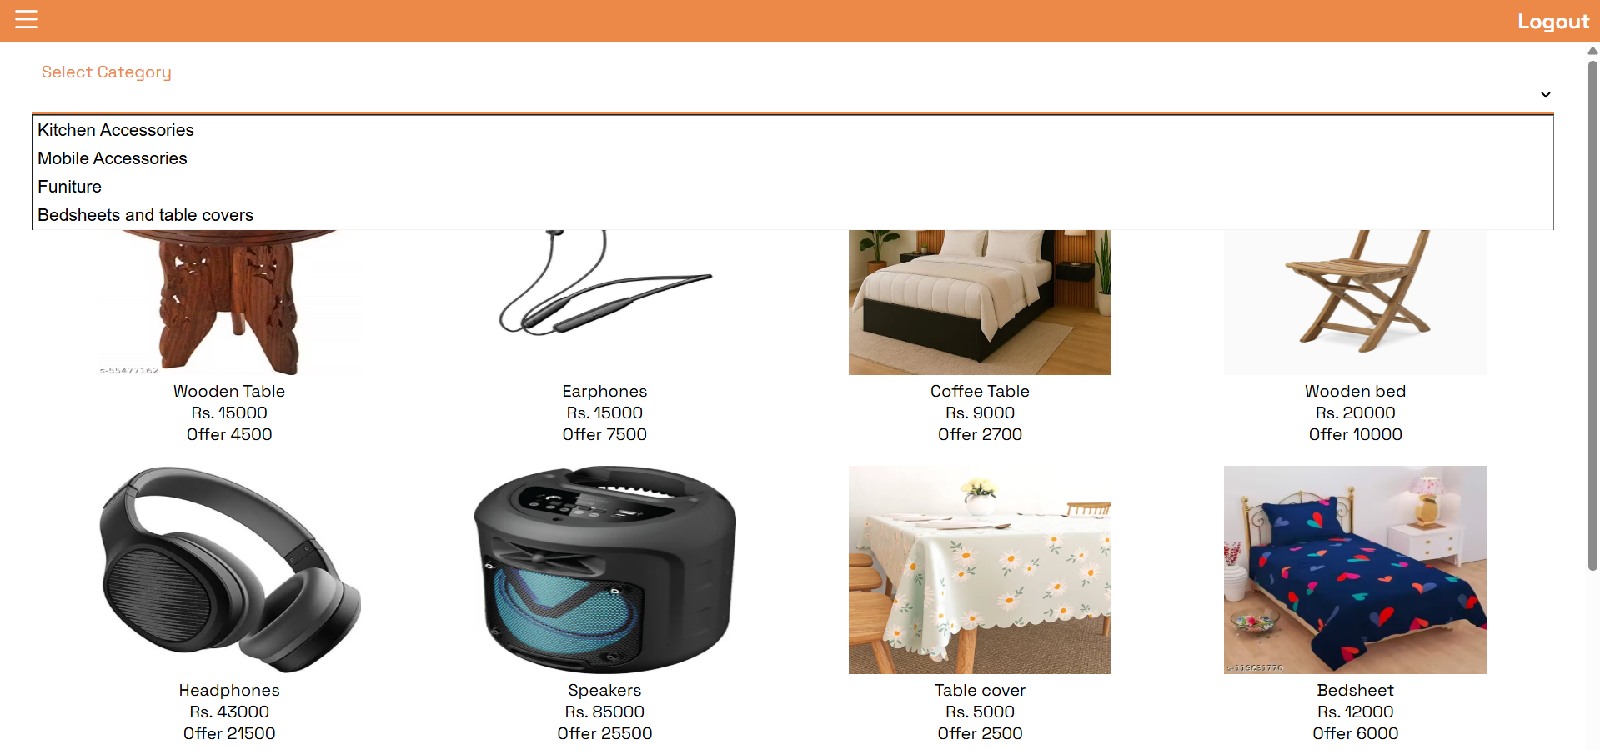



Offer wise:

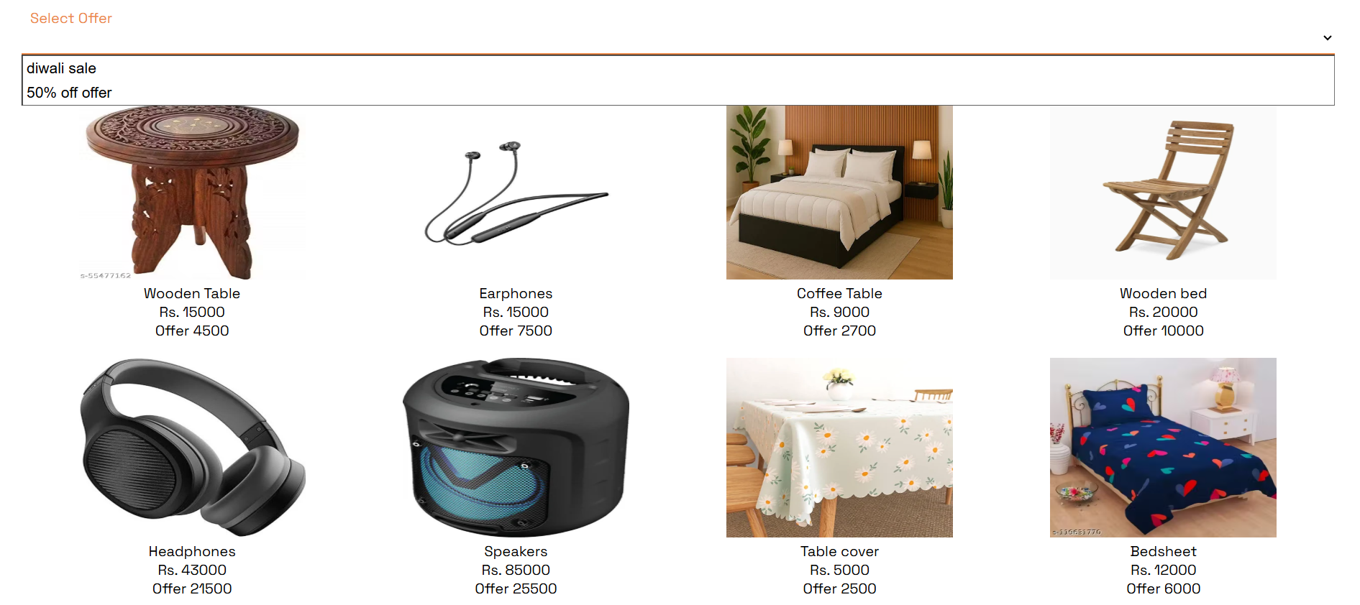



Shop wise:

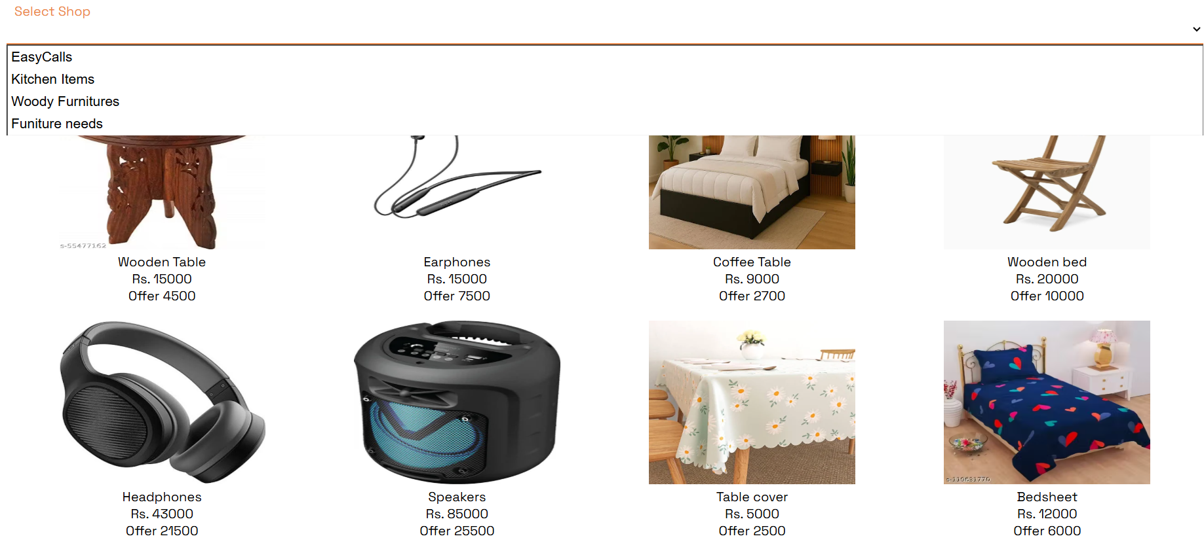



Floor wise:

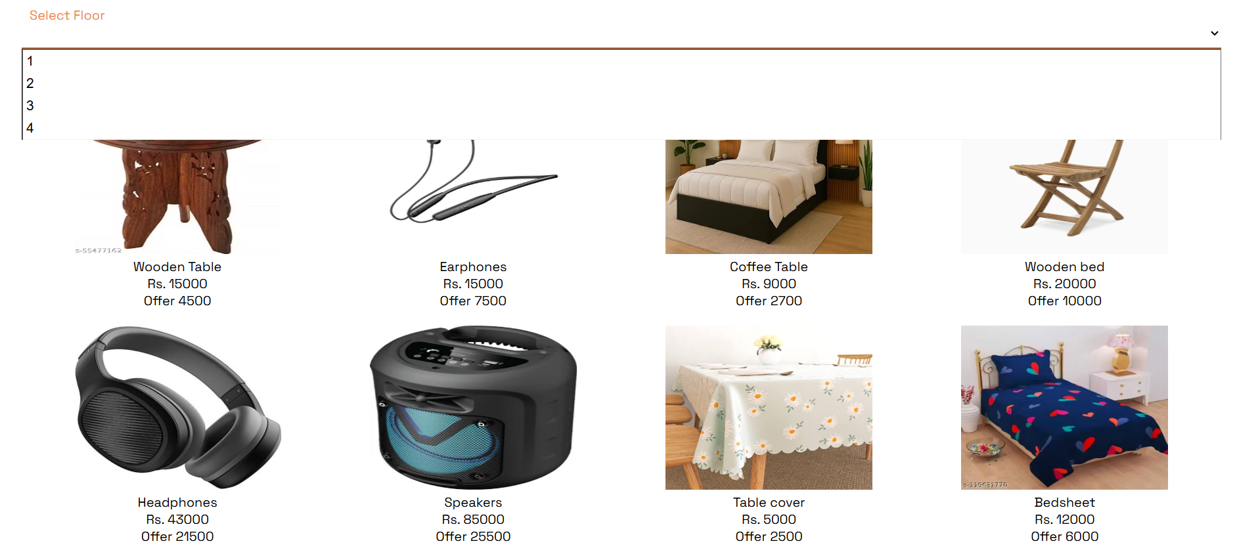



* The user can then logout.

Resize the screen to check the responsiveness of the application.